**Monitoring with Grafana, Loki and Prometheus**

Video Tutorial: <https://youtu.be/ddZjhv66o_o>

**Prerequisite**

* Basic Knowlege of Node.js and Express Framework
* Basic to Intermediate knowledge in Docker and Containerization - [Learn Docker Containerization](https://learn.piyushgarg.dev/learn/docker)

**Installation and Setup**

**1. Prometheus Server**

* Create a prometheus-config.yml file and copy the following configration. Don't forget to replace <NDOEJS_SERVER_ADDRESS> with actual value.

global:

scrape_interval: 4s

scrape_configs:

- job_name: prometheus

static_configs:

- targets: ["<NDOEJS_SERVER_ADDRESS>"]

* Start the Prometheus Server using docker compose

version: "3"

services:

prom-server:

image: prom/prometheus

ports:

- 9090:9090

volumes:

- ./prometheus.yml:/etc/prometheus/prometheus.yml

Great, The prometheus server is now up and running at PORT 9090

**2. Setup Grafana**

docker run -d -p 3000:3000 --name=grafana grafana/grafana-oss

[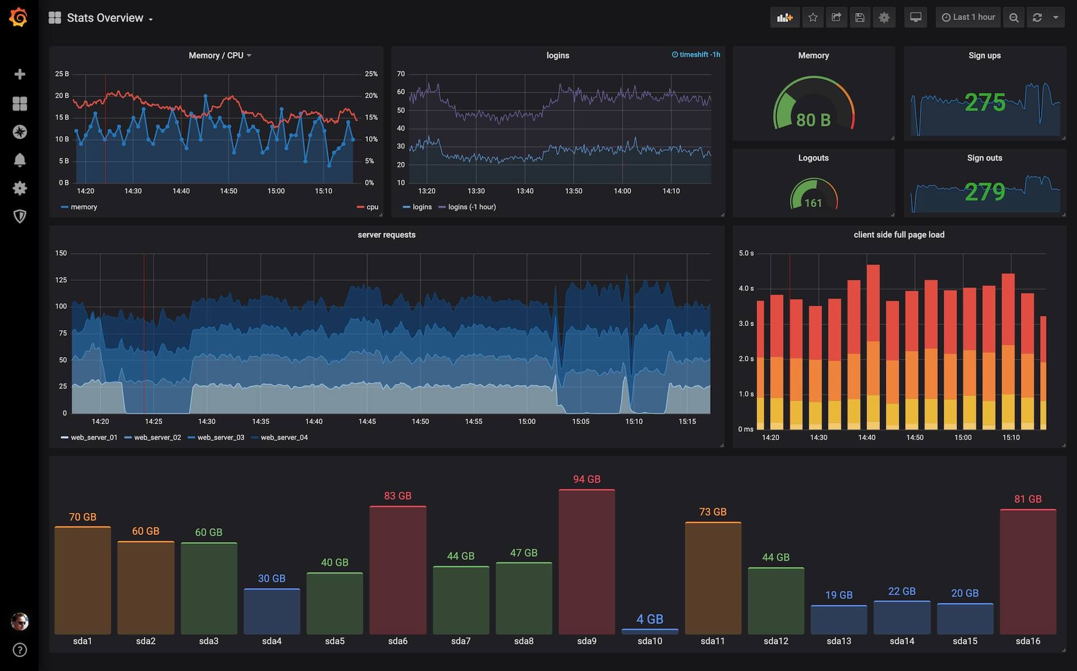](https://camo.githubusercontent.com/4d913b6d42202f417181ced43a39514a1bcb65597d71daf83ddaf33c72b1d236/68747470733a2f2f67726166616e612e636f6d2f7374617469632f696d672f67726166616e612f73686f77636173655f76697375616c697a652e6a7067)

**3. Setup Loki Server**

docker run -d --name=loki -p 3100:3100 grafana/loki